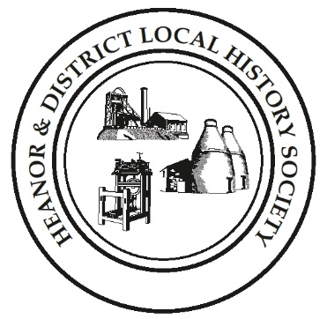
We want your memories! As part of an ongoing project, the Heanor & District Local History Society wants to hear from YOU.
We would like to establish a collection of people’s memories about the area - it can be from any period, and from any part of the district. And ANY subject - whether home life, work life, shopping, leisure. It doesn’t matter how trivial you may think your reminiscences are; they will help form part of a much bigger picture, which we can use to assist our future research, publications and newsletters.
This is nothing new of course; we have always asked for this from our members, but have now decided to use this method to try to prompt people to give information on specific issues.
So, every couple of months we will distribute a new form, on a different topic, and with different questions. There is no deadline. You don’t have to take part in all, or any, of the topics. Likewise, you don’t have to be a member to take part - all that we ask is that it is something to do with the Heanor area, or involved Heanor people. If you can think of someone else who may like to help, please feel free to pass a form onto them.
This month’s topic is: Church or Chapel?
How to pass the information onto us:
- If you normally attend our meetings, just fill in the form and hand it back at the next meeting.
- If you don’t attend our meetings, you can send us an email with the information (mail@heanorhistory.org.uk), or post the form to: Heanor & District Local History Society, 12 Walton Court, West Hallam, Ilkeston, DE7 6NS.
We would rather that you didn’t send us information anonymously, but nobody’s name will be published unless you have specifically given us permission to do so. In particular, we WILL NOT publish anything which of a personal or potentially sensitive nature.
Name | Address
Telephone
Email address
Are you willing for your name to be linked to any information supplied? |  | Yes / No
Would you be prepared to discuss this or related information further? |  | Yes / No

P.T.O.
This time, we would like you to share your memories of going to church or chapel when you were young.
Which church or chapel did you attend?
Roughly when was this, and what age were you?
What did the church/ chapel difference mean to you, if anything?
Tell us about any of the people you remember there? (The minister, Sunday School teachers, members of the choir, or just other people who went.)
Did you go to Sunday School, or services, or both? What time(s) of day were you there?
Did you go to any Sunday School events or anniversaries? Can you describe them?
What was the highlight of the year at the church or chapel? What took place?
Other than things already mentioned, is there any particular event or incident which stands out in your memory?
Please use a separate sheet if necessary. If you have any photographs of church/chapel events, we would love to see them. Thank you

